**Article Management System**

**Description:** Management system is defined as a strategic process of an organization based on a comprehensive framework of instructions and well-designed set of guiding rules, for undergoing organizational operations for achieving organization targets

In this project we have used:

Software tools: Node.js, React js,

Css Frameworks: Bootrap (for Responsive)

Testing Tools: Jest,engyme.

**Project Description:**

In this project redux for internal storage. And we have default user

Username: [admin@gmail.com](mailto:admin@gmail.com)

Password: 123456

When user is login in to system, should able to see managing articles. Like add Article and View,Update,Delete Articles

**LogIn Page:**

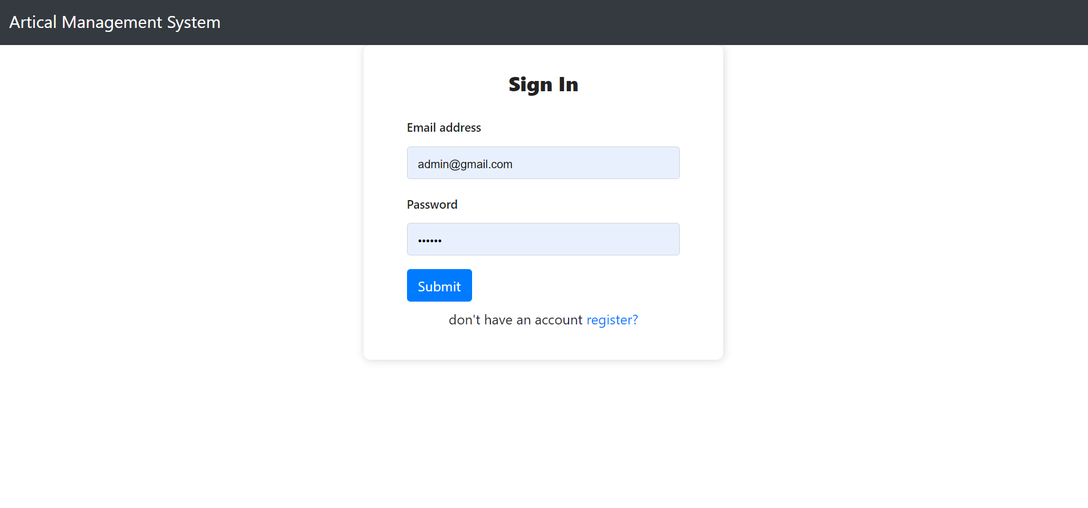

Register User:

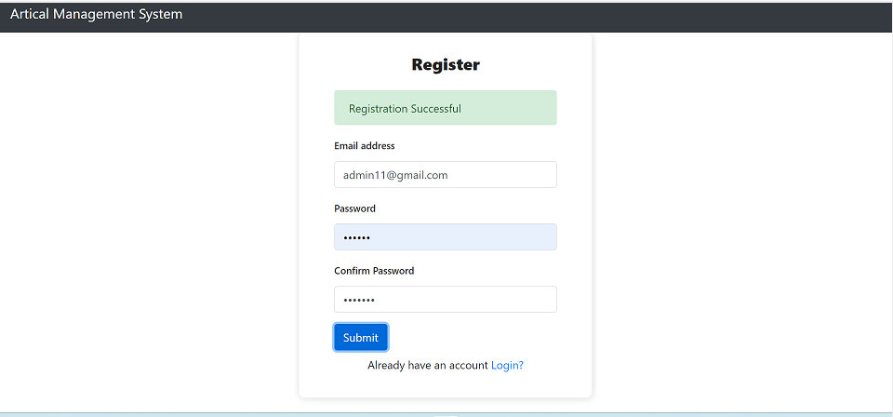

**User Landing Page:**

